**IBM PROJECT –PNT2022TMID26869**

Team Leader

VYDYULA MANOJA**(310519106091)**

Team Members

PARVATHI.J**(3105191047)**

SEETHA.I**(310519106069)**

SWATHI.B**(310519106082)**

Bachelor of Engineering In

Electronics and CommunicationEngineering

DHANALKSHMI SRINIVASAN COLLEGE OF ENGINEERING AND TECHNOLOGY MAMALLAPURAM, CHENNAI

|  |  |  |
| --- | --- | --- |
| **CHAPTER NO.** | **TABLE OFCONTENTS**  **TITLE** | **PAGE NO.** |
| **1** | **INTRODUCTION** |  |
|  | * 1. PROJECTOVERVIEW   2. PURPOSE | **1**  **1** |
| **2** | **LITERATURESURVEY** |  |
|  | * 1. EXISTINGPROBLEM   2. REFERENCES   3. PROBLEM STATEMENTDEFINITION | **2**  **3**  **4** |
| **3** | **IDEATION & PROPOSED SOLUTION** |  |
|  | * 1. EMPATHY MAPCANVAS   2. IDEATION &BRAINSTORMING   3. PROPOSEDSOLUTION   4. PROBLEM SOLUTIONFIT | **5**  **6**  **7**  **8** |
| **4** | **REQUIREMENT ANALYSIS** |  |
|  | * 1. FUNCTIONALREQUIREMENT   2. NON-FUNCTIONALREQUIREMENTS | **9**  **10** |
| **5** | **PROJECT DESIGN** |  |
|  | * 1. DATA FLOWDIAGRAMS   2. SOLUTION & TECHNICALARCHITECTURE   3. USERSTORIES | **11**  **12**  **14** |
| **6** | **PROJECT PLANNING& SCHEDULING** |  |
|  | * 1. SPRINTPLANNING&ESTIMATION   2. SPRINT DELIVERYSCHEDULE | **15**  **16** |
| **7** | **CODING AND SOLUTIONING** |  |
|  | * 1. FEATURE1   2. FEATURE2   3. DATABASESCHEMA | **17**  **17**  **18** |
| **8** | **TESTING**  8.1 TEST CASES |  |
|  | **21** |
| **9** | **RESULTS**  9.1 PERFOMANCEMETRICS |  |
|  | **22** |
| **10** | **ADVANTAGES & DISADVANTAGES** | **25** |
| **11** | **CONCLUSION** | **27** |
| **12** | **FUTURE SCOPE** | **28** |
| **13** | **APPENDIX**  Ii | **29** |

# CHAPTER 1

**INTRODUCTION**

* 1. **PROJECTOVERVIEW**

## This projectaimstodesign andimplementacombinationofIoTandApplication Development based Waste Management Systems. The combination of IoT and Application Development has plenty of applications such as home security systems, payment technologies, intruder recognition systems, etc. This research utilizestheapplicationforWasteManagement.Thekit consistsofhardwareand software parts. The hardware part comprises a sensor unit, which detects the volume of waste present in the bin, a weight-detecting garbage system, a GPS locator,andaGSMmoduletocommunicatewithamobiledevice.The software partusesPythoncodesandCcodes.

* 1. **PURPOSE**

The purpose of this project is a small step to Reduce Air, Water, and Soil Pollution. The world faces major environmental challenges associated with waste generation and inadequate waste collection, transport, treatment, and disposal. It is a matter of health safety. Tuberculosis, pneumonia, diarrhoea, tetanus, whooping cough, etc. are other common diseases spread due to improper waste management. The toxic wastes can lead to different kinds of pollution - air, water, and soil. Our current systems cannot cope with the volumes of waste generated by an increasingly urban population and this has ahugeimpactontheenvironmentandpublichealth.Itreduces manuallabour, increases sustainable development, and reduces common health issues related toimproperwastemanagementtechniques.

**CHAPTER 2**

**LITERATURESURVEY**

* 1. **EXISTINGPROBLEM**

Wastemanagementplaysacrucialrolethesedays.Asenvironmentalconcerns grow,wastesaretobeproperlymanagedandrecycled.Impropermanagement will lead to air pollution, and soil erosion may even affect human health. Lisa Safer, etal.enhancethepointaboutthehealthimpactsofincineration,landfill, composting, land spreading sewage sludge, and sewage discharges. A step to reducetherisksistheproposedworkofwastemanagementusingIoT.Gopal Krishna Shyam, et al. submitted a work that utilizes sensors and uses an IoT algorithm that can read, collect, and transmit a huge volume of data over the Internet.Thesedata,whenputintoa Spatio-temporalcontextandprocessedby intelligent and optimized algorithms, can be dynamically handled by waste collection processes. The published work by Tran Anh Khoa et al put forth a low-cost IoT architecture that efficiently achieves waste management by predicting the probability of the waste level in trash bins, using machine learning and graph theory, and determining the shortest path of waste collection. It also examines the data transfer on the LoRa module and demonstrates the advantages of the system, which is implemented through a simple circuit designed with low cost, ease of use, and replaceability. "Challenges and Opportunities of Waste Management in IoT-Enabled Smart Cities: A Survey" by Theodoros Anagnostopoulos, etal. gives detailed information on various aspects of IoT in waste management. With the above references, this project proposes a Smart Waste Management System For MetropolitanCitiesthatdetectsthelevelof Garbageinbins,andtheweightof the garbage in the bin and alerts the authorized person to empty the bin whenever the bins are full. With further advancements, the Garbage level of thebinscanbemonitoredthroughaWebAppthroughwhichwecanviewthe locationofeverybinbysendingGPSlocationfromthedevice.

* 1. **REFERENCES**

1. Shyam, Gopal Kirshna, Sunilkumar S. Manvi, and Priyanka Bharti. "Smart waste management using Internet-of-Things (IoT)." IEEE Computing and Communications Technologies (ICCCT), (2017) pp. 199-203.
2. Kurre, Vishesh Kumar."Smart Garbage Collection Bin overflows IndicatorusingIOT."InternationalResearchJournalofEngineeringand Technology (IRJET)(2016).
3. Folianto, Fachmin, Yong Sheng Low, and Wai Leong Yeow. "Smartbin: Smart waste management system." Tenth IEEE International conference on Intelligent Sensors, Sensor Networks and Information Processing (ISSNIP), (2015).
4. Vu, Dung, and Georges Kaddoum. "A wastecity management system for smart cities applications." (2017).2017 Advances in Wireless and Optical Communications
5. Kumar, S. Vinoth, T. Senthil Kumaran, A. Krishna Kumar, and MahanteshMathapati. "Smart garbage monitoring and clearance system using internetofthings."IEEESmartTechnologiesandManagementfor

Computing, Communication, Controls, Energy and Materials, (2017).

1. Swati Dewangan,IoT- Enabled Intelligent Solid Waste ManagementSystem forSmartCity:ASurvey,ISSNNO:2249-7455
2. AmooOM,FangbaleRL(2013).Renewablemunicipalsolidwaste

pathways for energy generation and sustainable development in the Nigerian context. International Journal of Energy and Environmental Engineering, 4(1):

42.J.H. Chuang. Potential-Based Approach for Shape Matching and Recognition. Pattern Recognition,

* 1. **PROBLEM STATEMENTDEFINITION**

Waste management in metropolitan cities faces numerous challenges. The main problem faced by the metropolitan cities are detecting the garbage level weather it filled or not and also we need to measure the weight of the garbage bin. Then alertstheauthorizedpersontoemptythebinwheneverthebinsarefull.Weneed to develop a web application to monitor the status of the bins remotely at anywhere.Theapplicationshouldprovidethelocationoftheeverybinconnected in the application with the help of global positioning system (GPS). The indicationofthebinsandthelocationoftheeverybinshouldbeprovidedbyweb applicationssimultaneously.

**CHAPTER 3**

**IDEATION & PROPOSED SOLUTION**

* 1. **EMPATHY MAPCANVAS**

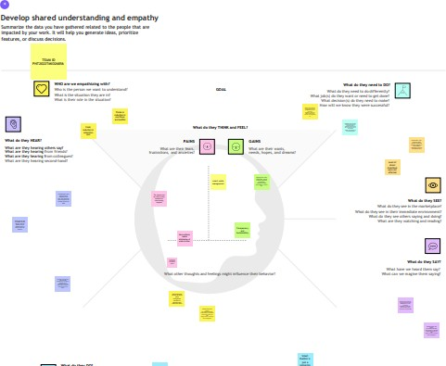

* 1. **IDEATION &PROCESSIING**

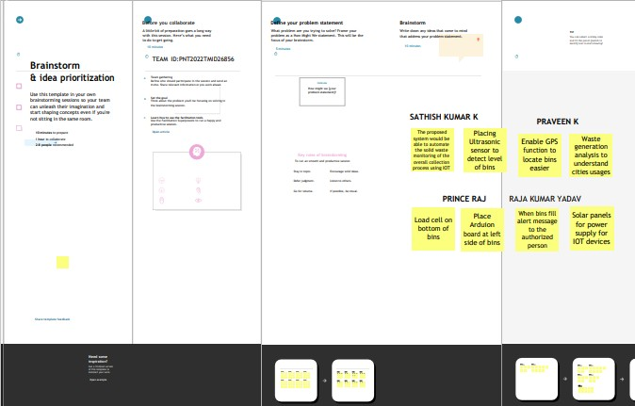

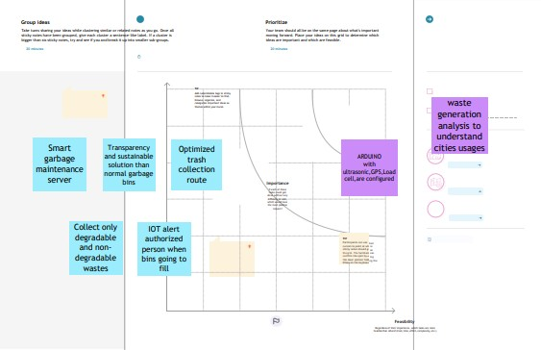

* 1. **PROPOSEDSOLUTION**

|  |  |  |
| --- | --- | --- |
| **S. No.** | **Parameter** | **Description** |
| 1. | Problem Statement (Problem to be solved) | To develop economic waste management  system foreach village and city |
| 2. | Idea / Solution description | To seggregate the different types of wastes by using modern technologies. |
| 3. | Novelty / Uniqueness | Trash talker, Image processing technique, using rasperry PI camera,pick up hand, conveyor belt  ,hand sensor smart bins,giving notifcaton by sector alarm. |
| 4. | Social Impact / Customer Satisfaction | By implementing this we can make our environment clean and control the spreading of infectious diseases from garbage |
| 5. | Scalability of the Solution | Image processing technique , Conveyor belt, pick up hand, Trash talker and sensors are usedto separate the wastes , control the overfow of  waste and gives alarm to the respective sector. |

* 1. **PROBLEMSOLUTIONFIT**

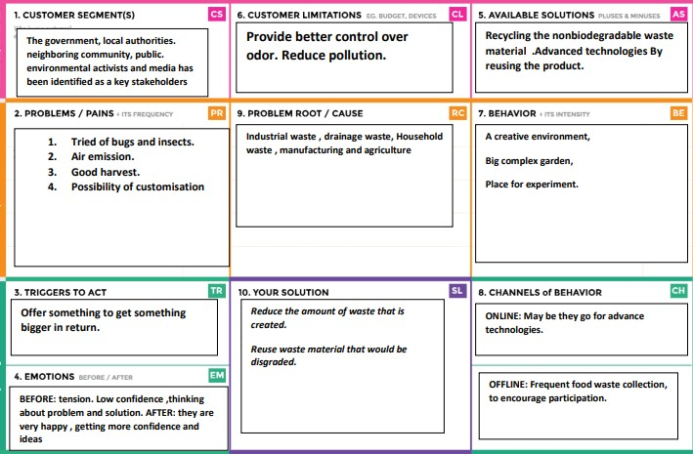

**CHAPTER 4 REQUIRMENT ANALYSIS**

* 1. **FUNCTIONAL REQUIREMENT FunctionalRequirements:**

Following are the functional requirements of the proposed solution.

* 1. **NON-FUNCTIONALREQUIREMENTS**

### Non-functional Requirements:

Following are the non-functional requirements of the proposed solution.

|  |  |  |
| --- | --- | --- |
| **NFR**  **No.** | **Non-Functional Requirement** | **Description** |
| 1 | **USABILITY** | IoT device verifies that usability is a special and important perspective to analyze user requirements, which can further improve the design quality. In the design process with user experience as the core, the analysis of users’ product usability can indeed help designers better understand users’ potential needsin waste management, behavior and experience. |
| 2 | **SECURITY** | Use a reusable bottles Use reusable grocery bags Compostit  Purchase wisely and recycle  Avoid using use and throw food and drink containers. |
| 3 | **RELIABILITY** | Smart waste management is also about creating better working conditions for waste collectors and drivers. Instead of driving the same collection routes and servicing empty bins, waste collectors will spend their time more efficiently, taking care of bins that needservicing. |
| 4 | **PERFORMANCE** | The Smart Sensors use ultrasound technology to measure the fill levels (along with other data) in bins several times a day. Using a variety of IoT networks (NB-IoT,GPRS), the sensors send the data to Sensoneo’s Smart Waste Management Software System, a powerful cloud-based platform, for datadriven daily operations, available also as a waste management app.  Customers are hence provided data-driven decision making, and optimization of waste collection routes, frequencies, and vehicle loads resulting in route reduction by at least 30%. |

**CHAPTER 5**

**PROJECT DESIGN**

* 1. **ProjectDesignPhase-IIDataFlowDiagram&UserStories**

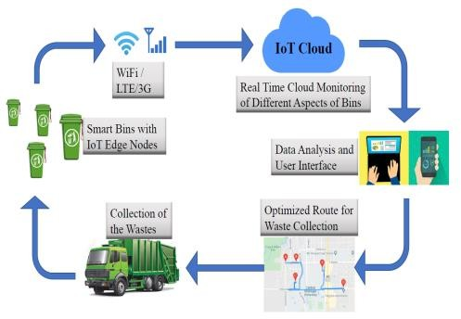

* 1. **SOLUTION ARCHITECTURE**

**Design**

* + - Garbageleveldetectioninbins.
    - Gettingtheweightofthegarbageinthebin.
    - Alertstheauthorizedpersontoemptythebinwheneverthebinsarefull.
    - Garbagelevelofthebinscan bemonitoredthroughawebApp.
    - We can view the location of every bin in the web application bysending GPSlocationfromthedevice.

**Software and system required:**

* + - PythonIDLE
    - 4GBprocessorandOS-Windows/Linux/MAC

**Block diagram:**

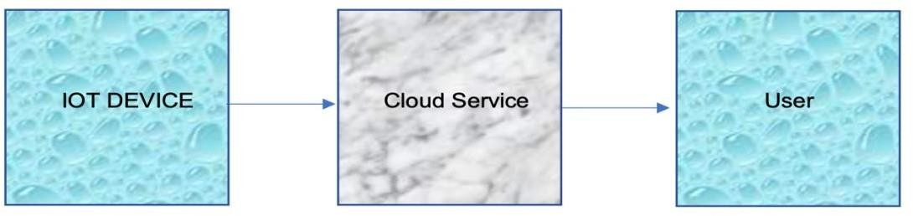

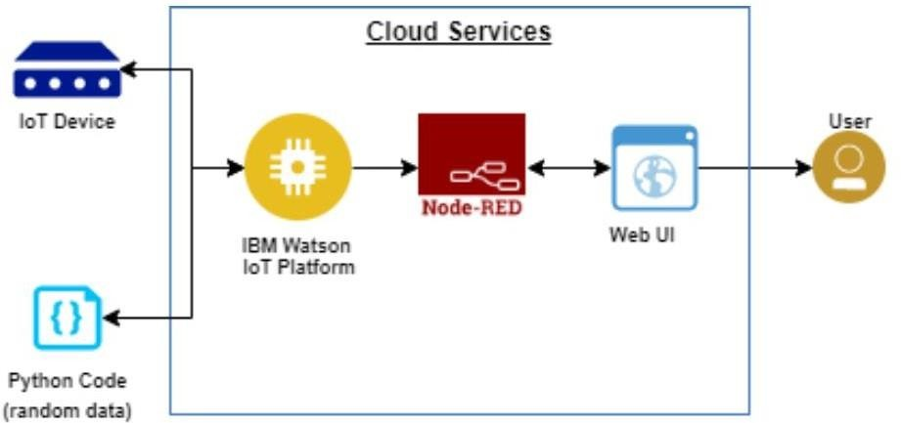

IOT Device

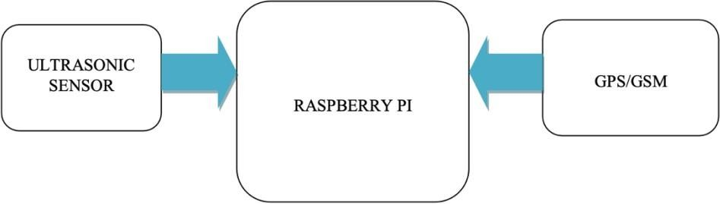

Cloud service:

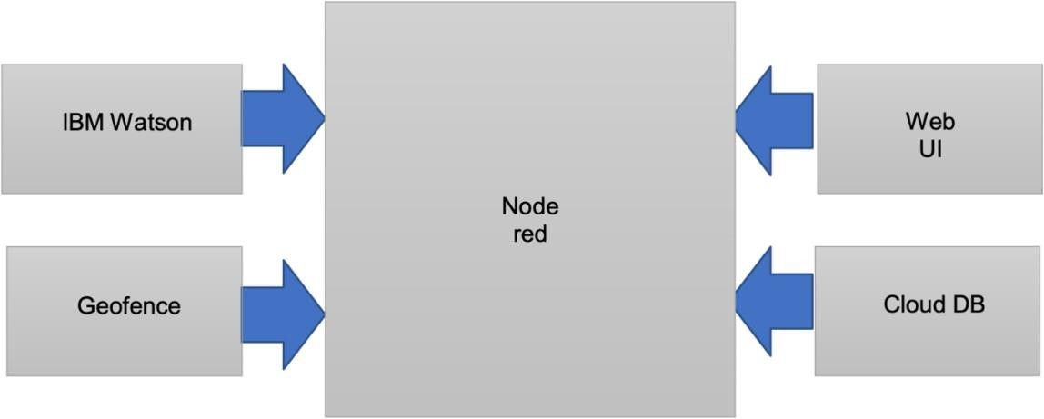

* 1. **USERSTORIES**

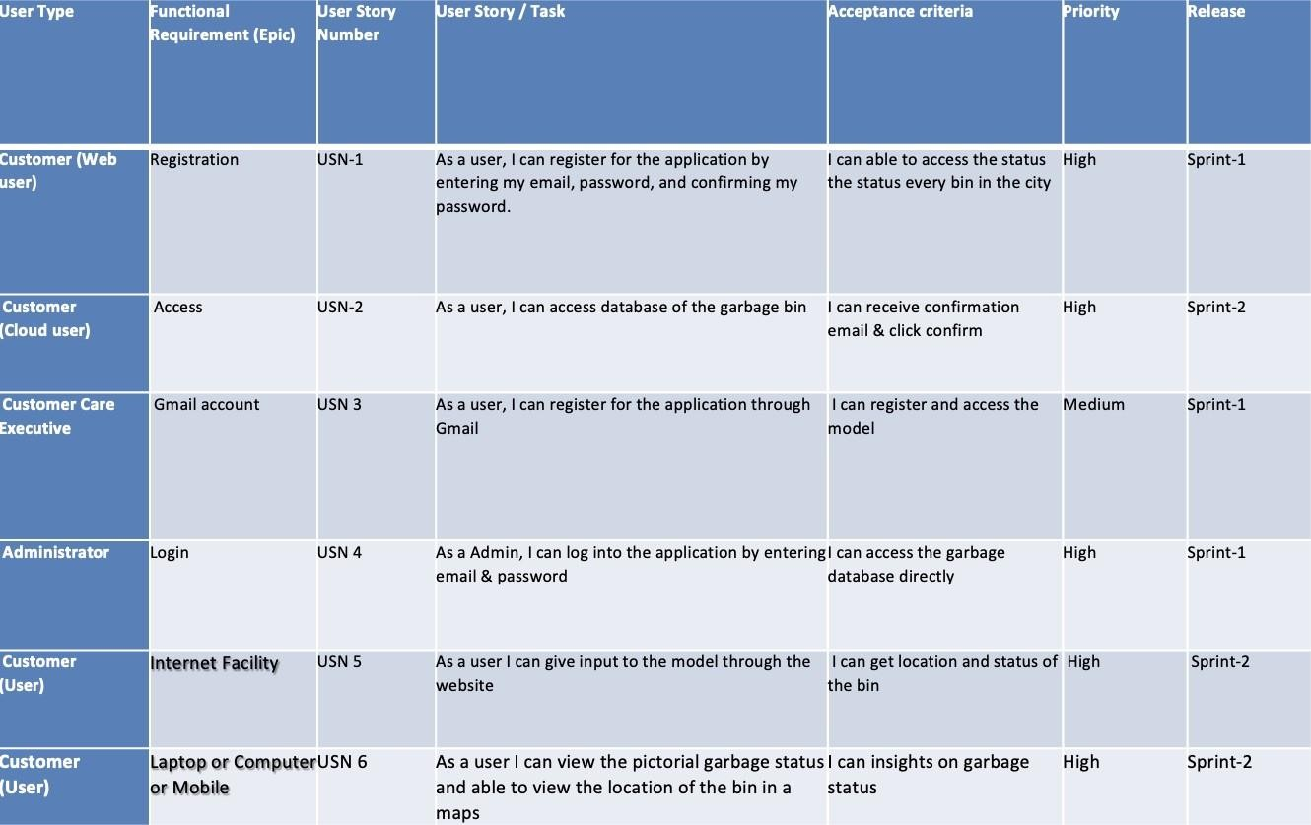

|  |  |  |  |
| --- | --- | --- | --- |
| **CHAPTER 6**  **PROJECT PLANNING& SCHEDULING**  **6.1 Sprint Planning& Estimation** | | | |
|  | **TITLE** | **DESCRIPTION** | **DATE** |
| **Literature Survey & Information Gathering** | Literature survey on the selected project & gathering information by referring the, technical papers,research publications etc. | 14SEPTEMBER 2022 |
| **Prepare Empathy Map** | Prepare Empathy Map Canvas to capture the user Pains & Gains, Prepare list of problem statements | 25SEPTEMBER 2022 |
| **Ideation** | List the by organizing the  brainstorming session and prioritize the top 3 ideas based on the feasibility & importance. | 26 SEPTEMBER 2022 |
| **Proposed Solution** | Prepare the proposed solution document, which includes the novelty, feasibility of idea, business model, social impact, scalability of solution, etc. | 24SEPTEMBER 2022 |
| **Problem Solution Fit** | Prepare problem - solution fit document. | 03 OCTOBER 2022 |
| **Solution Architecture** | Prepare solution architecture document. | 04 OCTOBER 2022 |
| 15 | | | |

**6.2 Sprint Delivery Schedule**

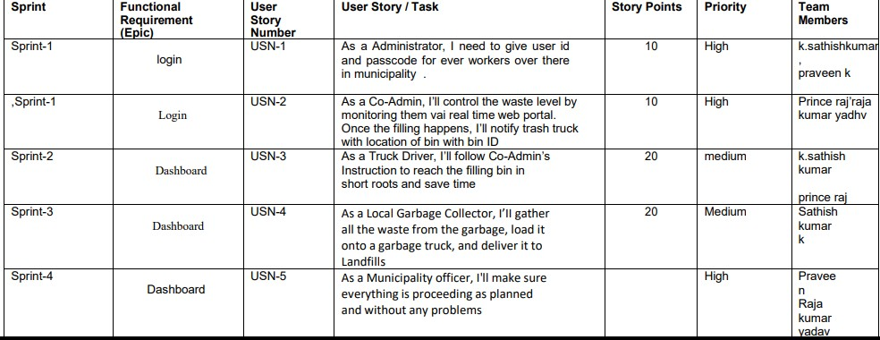

**Project Tracker, Velocity & Burndown Chart:**

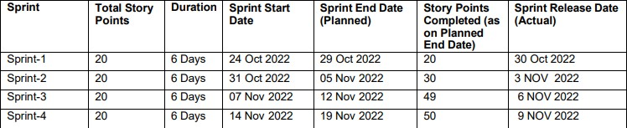

**Velocity:**

Imaginewehavea10-daysprintduration,andthevelocityoftheteamis20(pointspersprint). Let’scalculatetheteam’saveragevelocity(AV)periterationunit(storypointsperday)

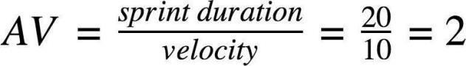

**CHAPTER 7**

**CODING & SOLUTION**

* 1. **Feature 1**
     + IOTDEVICE
     + WOKWISOFTWARE
     + IOT WATSONPLATFORM
     + NODERED
     + WEBUI
     + CLOUDANTDB
  2. **Feature 2**
     + REGISTRATION
     + LOGIN
     + VERIFICATION
     + SELECT THECITY
     + DISPLAYTHESTATUSOFBIN
     + ADDQUERY

**7.3. DATA BASE SCHEME**

|  |
| --- |
| constcap_status=document.getElementById('cap_status');  const alert_msg = document.getElementById('alert_msg'); |
| var ref = firebase.database().ref(); |
| ref.on("value", function(snapshot) |
| { |
| snapshot.forEach(function (childSnapshot){ |
| var value= childSnapshot.val(); |
| const alert_msg_val = value.alert; |
| constcap_status_val = value.distance_status; |
| alert_msg.innerHTML= `${alert_msg_val}`; |
| }); |
| }, function (error){ |
| console.log("Error: " + error.code); |
| }); |

**CHAPTER 8**

**TESTING**

**8.1 Test Cases**

SNO

TEST CASE

FEATURE

STEPS TO EXECUTE

EXPECTEDRESULT

ACTUAL RESULT

EXECUTED BY

1. FUNCTIONAL

LOGIN

LOGIN TO EXECUTE BY FILLING THE DETAILS

CORRECT LOGIN CREDENTIALS

WORKING AS EXPECTED

**VYDYULA MANOJA**

1. FUNCTIONAL

REGISTRATION

REGISTRATION THROUGH FORMS

REGISTRATION FORM TO BE FILLED AND DISPLAYED

WORKING AS EXPECTED

PARVATHI.J

1. FUNCTIONAL

WOKWI

TODEVELOPTHE IOTDEVICEAND CODE THE IOT DEVICE

SENSETHEDATA

WORKING AS EXPECTED

SWATHI.B

1. FUNCTIONAL

IBMWATSON

PUSH THE SENSED DATA FROM WOKWI

SENSEDDATA IN IBM WATSON

WORKING AS EXPECTED

SEETHA.I

1. FUNCTIONAL

NODERED

TO CONNECT WITH THE IBM WATSON AND THEN COLLECT THE SENSED DATA AND DISPLAYINNODE REDDASHBOARD

VISUAL REPRESENTATION OF SENSED DATA IN NODE RED DASHBOARD

WORKING AS EXPECTED

VYDYULA MANOJA AND PARVATHI.J

1. TESTING

TEST THE ENTIRE WORK

TO CHECK ALL THE MENTIONED TESTCASE ARE WORKING PROPERLY

TEST CASE ARE WOKINGPROPERLY

WORKING AS EXPECTED

PARVATHI.J

SWATHI.B

SEETHA.I

# CHAPTER 9

**RESULTS**

* 1. **PerfomanceMetrics**
     + **IOTDEVICESIMULATIONINWOKWISOFTWARE**

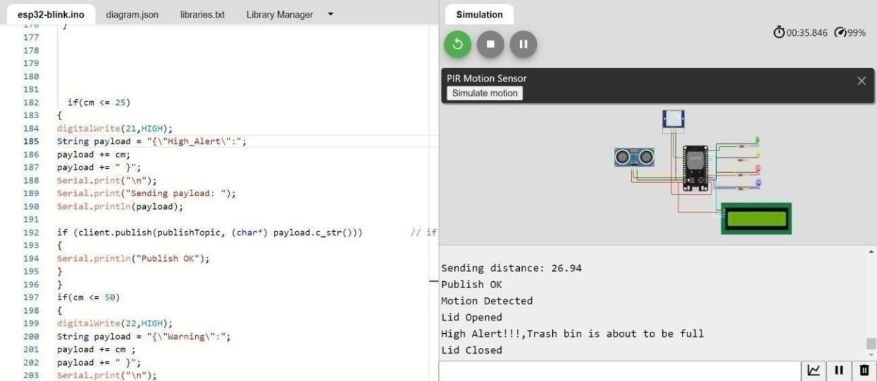

* + - **SENSEDTHEDATAVISUALIZATIONINIBMWATSON**

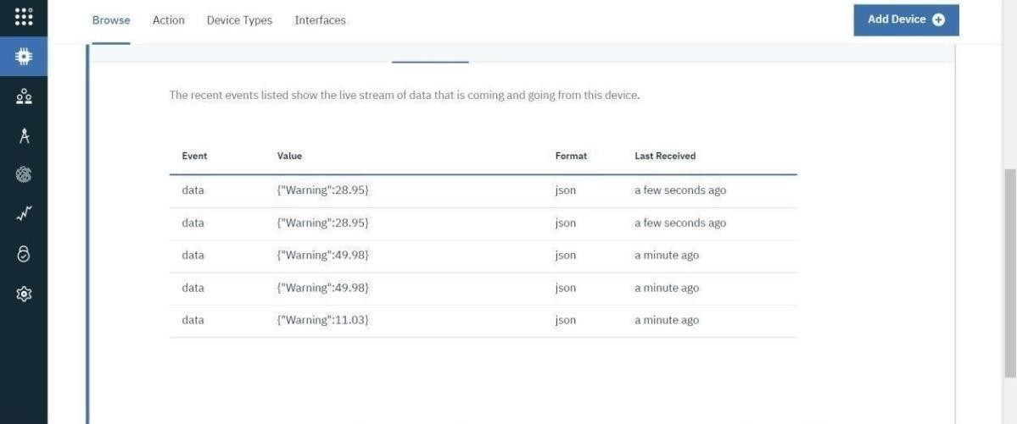

* + - NODE REDCONNCETIONS

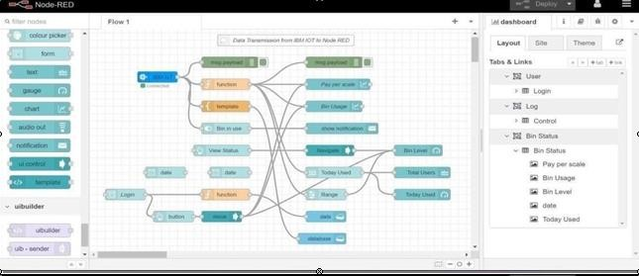

* + - VISUALIZATIONOFSENSEDDATAINNODEREDDASHBOARD

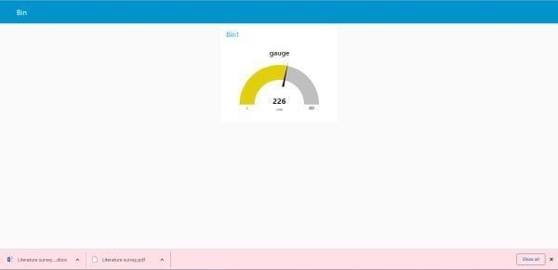

**CHAPTER 10**

**ADVANTAGES & DISADVANTAGES**

**Advantages**

The advantage of using this system is that it overcomes the health and environmental hazards of improper waste management processes to a certain extent.Thiscannotbetheonlysolutionbutoneofthesolutionstosustainable development.Theuseofsolarpanels toproducetherequiredenergycanbeof greatuseasit isnotarenewableresource,butitpowersthesensorfordetection and the IoT Devices present in the Truck for real-time GPS Tracker. This systemischeapandveryefficient.Thedoor-todoorcollectionalsohelps the differently abled to manage the waste properly. The utilization of simple everydaygadgetsmakesit easytounderstandfor thecustomerstocompletely use the product. Anyone from age 5-90 can use the product. This is not the restriction that is mentioned but the ease and comfort of the app for all ages. Oneofthemainadvantages isthatawarenessis createdamongtheusers.They come to know about the anthropocentric character that degrades the environmenttoagreat levelandinturnaffectshealth.Thisactsasachangeor at least a motivation to a certain extent to support, love and care for mother Earthwhichhasdoneeverythingtosatisfyourneedsandallwedoisdegrade it.Butit’stimewerepayit,helpherandstoptheantagonist's torture,andlive happily.

**Disadvantages**

If something has a lot of positive effects there would be something negative. Nothingcanbeperfectorinanidealcondition.Allwecandoissatisfyacertain levelandmakeitmoreadvantageousthanconsideringthedisadvantages.One ofthesekindsistheadaptationtothenewtechnologywouldtakealotoftime to get accustomed to as a daily life habit. Another disadvantage is considering security.Well-securedinformationfortheuserwillcostalotandwouldmake theprojectamorereliableone,astheuser’spersonalinformationiscollected, it is the owner’s responsibility or the creator's responsibility to make it with a desirable or highly secured system. Considering the high competition in this market, the initial cost would be high. Investing in a good cause makes us satisfied. Investing in a profitable system makes us innovate more but the drawback is that in the initial stages a very high amount is expected or compelledtobespenttomarketoradvertisetheproduct.

**CHAPTER 11 CONCLUSION**

A proper waste management system is essential for sustainable development.

This would be a small step towards a developing nation overcoming the limitationsofwastemanagement.Thisstepsecuresusfromtheenvironmental andhealthhazardsthatarebeinginducedasaslowpoisonisinterrelated.The technologyinthis periodofthe21stcenturyrefines usandthesurroundingsto abetterpersonaandabetterplacetolive.Itisthetimewhenwehavetobring inchangeandportrayrespect,loveandcaretowardthebeings thathavehelped usforoursurvival.Thereis asolution.And,thisProject isjustoneverysmall partofit.

**CHAPTER 12**

**FUTURE SCOPE**

A proper waste management system is essential for sustainable development. This would be a small step towards a developing nation overcoming the limitationsofwastemanagement.Thisstepsecuresusfromtheenvironmental andhealthhazardsthatarebeinginducedasaslowpoisonisinterrelated.The technologyinthis periodofthe21stcenturyrefines usandthesurroundingsto abetterpersonaandabetterplacetolive.Itisthetimewhenwehavetobring inchangeandportrayrespect,loveandcaretowardthebeingsthathavehelped usforoursurvival.Thereis asolution.And,thisProjectis justoneverysmall partofit.

**CHAPTER 13**

**APPENDIX**

SOURCE CODE

* + - Code for IoT devicein Wokwi

#include <LiquidCrystal_I2C.h>

LiquidCrystal_I2C lcd(0x27, 16, 2); // I2C address 0x3F, 16 column and 2 rows int trigPin=9; // TRIGpin

int echoPin = 8; // ECHO pin

float duration_us, distance_cm,distance; void setup() {

lcd.init(); // initialize the lcd lcd.backlight(); pinMode(7,OUTPUT); pinMode(6,OUTPUT); pinMode(5,OUTPUT);

pinMode(4,OUTPUT); // open the backlight pinMode(trigPin, OUTPUT); // config trigger pin to output mode pinMode(echoPin, INPUT); // config echo pin to inputmode

}

void loop() {

// generate 10-microsecond pulse to TRIG pin digitalWrite(trigPin, HIGH); delayMicroseconds(10); digitalWrite(trigPin,LOW);

// measure duration of pulse from ECHO pin duration_us = pulseIn(echoPin, HIGH);

// calculate the distance distance_cm = 0.017 * duration_us; distance=400-distance_cm; lcd.clear();

lcd.setCursor(0, 0); // start to print at the first row lcd.print("waste level: ");

lcd.print(distance); digitalWrite(6,HIGH); digitalWrite(7,LOW); digitalWrite(5,LOW); digitalWrite(4,LOW); if(distance>=175)

{

digitalWrite(5,HIGH); digitalWrite(6,LOW); digitalWrite(7,LOW); digitalWrite(4,LOW);

}

if(distance>=275)

{

digitalWrite(4,HIGH); digitalWrite(6,LOW); digitalWrite(5,LOW); digitalWrite(7,LOW);

}

if(distance>=375)

{

digitalWrite(7,HIGH); digitalWrite(6,LOW); digitalWrite(5,LOW); digitalWrite(4,LOW);

}

delay(500);

}

* + - CodeforconnectingtoIoTWatson

#include <LiquidCrystal_I2C.h> #include <WiFi.h>

#include <PubSubClient.h>

#include<WiFiClient.h>

LiquidCrystal_I2C lcd(0x27, 20, 4); // I2C address 0x3F, 16 column and 2 rows

int trigPin=2; // TRIGpin

int echoPin = 15; // ECHO pin

#define ORG "qippa4"

#define DEVICE_TYPE "Esp32" #define DEVICE_ID "Waste"

#define TOKEN "C72(GeQy)UPSVtHdUw"

char server[] = ORG ".messaging.internetofthings.ibmcloud.com"; // server name char publishTopic[] = "iot-2/evt/data/fmt/json";

char topic[] = "iot-2/cmd/led/fmt/String"; // cmd Represent type and command is test format of strings char authMethod[] = "use-token-auth"; // authentication method

char token[] = TOKEN;

char clientId[] = "d:" ORG ":" DEVICE_TYPE ":" DEVICE_ID; //Client id

WiFiClient wifiClient; // creating instance for wifi PubSubClient client(server, 1883, wifiClient);

void setup() {

lcd.init(); // initialize the lcd lcd.backlight(); pinMode(5,OUTPUT); pinMode(18,OUTPUT); pinMode(19,OUTPUT); pinMode(23,OUTPUT); pinMode(34,INPUT); pinMode(14,OUTPUT);

// open the backlight

pinMode(trigPin, OUTPUT); // config trigger pin to output mode pinMode(echoPin, INPUT);

Serial.begin(115200); wifiConnect(); mqttConnect();

// config echo pin to input mode

}

float readcmCM()

{

digitalWrite(trigPin, LOW); delayMicroseconds(2); digitalWrite(trigPin, HIGH); delayMicroseconds(10); digitalWrite(trigPin, LOW);

int duration = pulseIn(echoPin, HIGH); return duration * 0.034 / 2;

}

voidloop()

{

lcd.clear();

publishData(); delay(500);

if (!client.loop())

{

mqttConnect(); // function call to connect to IBM

}

}

/* -retrieving to cloud */

void wifiConnect()

{

Serial.print("Connecting to "); Serial.print("Wifi");

WiFi.begin("Wokwi-GUEST", "", 6);

while (WiFi.status() != WL_CONNECTED)

{

delay(500); Serial.print(".");

}

Serial.print("WiFi connected, IP address: "); Serial.println(WiFi.localIP());

}

void mqttConnect()

{

if (!client.connected()) Serial.print("Reconnecting MQTT client to "); Serial.println(server);

while (!client.connect(clientId, authMethod, token))

{

Serial.print("."); delay(500);

}

initManagedDevice(); Serial.println();

}

}

void initManagedDevice()

{

if (client.subscribe(topic))

{

Serial.println("IBM subscribe to cmd OK");

}

else

{

Serial.println("subscribe to cmd FAILED");

}

}

void publishData()

{

float cm = readcmCM();

if(digitalRead(34))

{

Serial.println("Motion Detected"); Serial.println("Lid Opened"); digitalWrite(14, HIGH);

}

else

{

digitalWrite(14, LOW);

} //PIR motion detection

if(digitalRead(34))

{

if(cm <= 100)

//Bin level detection

{

digitalWrite(23, HIGH);

Serial.println("High Alert!!!,Trash bin is about to be full"); Serial.println("Lid Closed");

lcd.print("Full! Don't use"); delay(2000);

lcd.clear(); digitalWrite(18,LOW); digitalWrite(19,LOW); digitalWrite(5,LOW);

}

else if(cm > 100 && cm < 200)

{

digitalWrite(5,HIGH);

Serial.println("Warning!!,Trash is about to cross 75% of bin level"); digitalWrite(18,LOW);

digitalWrite(19,LOW); digitalWrite(23,LOW);

}

else if(cm > 200 && cm < 300)

{

digitalWrite(18, HIGH);

Serial.println("Warning!!,Trash is about to cross 50% of bin level"); digitalWrite(5,LOW);

digitalWrite(19,LOW); digitalWrite(23,LOW);

}

else if(cm > 300 && cm <=400)

{

digitalWrite(19, HIGH); Serial.println("Bin is available"); digitalWrite(5,LOW); digitalWrite(18,LOW); digitalWrite(23,LOW);

}

delay(10000); Serial.println("Lid Closed");

}

else

{

Serial.println("No motion detected");

}

if(cm <= 100)

{

digitalWrite(21,HIGH);

String payload = "{\"High Alert!!\":\"";payload += cm; payload += "left\" }"; Serial.print("\n");

Serial.print("Sending payload: "); Serial.println(payload);

if (client.publish(publishTopic, (char*) payload.c_str()))

// if data is uploaded to cloud successfully,prints publish ok or prints publish failed

{

Serial.println("Publish OK");

}

}

if(cm <= 250)

{

digitalWrite(22,HIGH);

String payload = "{\"Warning!!\":\"";payload+= cm; payload += "left\" }"; Serial.print("\n");

Serial.print("Sending distance: ");

Serial.println(cm);

if(client.publish(publishTopic, (char*) payload.c_str()))

{

Serial.println("Publish OK");

}

else

{

Serial.println("Publish FAILED");

}

}

float inches = (cm / 2.54); //print on LCD lcd.setCursor(0,0);

lcd.print("Inches"); lcd.setCursor(4,0); lcd.setCursor(12,0); lcd.print("cm"); lcd.setCursor(1,1); lcd.print(inches, 1); lcd.setCursor(11,1); lcd.print(cm,1); lcd.setCursor(14,1);

delay(1000);

lcd.clear();

}

## Code forlogin page

<html>

<head>

<meta name="viewport" content="width=device-width, initial-scale=1">

<style>

body {font-family: Arial, Helvetica, sans-serif;}

/* Full-width input fields */ input[type=text], input[type=password] { width: 100%;

padding: 12px 20px; margin: 8px 0; display: inline-block; border: 1px solid #ccc; box-sizing:border-box;

}

/* Set a style for all buttons */ button {

background-color: #04AA6D; color: white;

padding: 14px 20px; margin: 8px 0; border: none; cursor: pointer; width: 100%;

}

button:hover { opacity: 0.8;

}

/* Extra styles for the cancel button */

.cancelbtn { width: auto;

padding: 10px 18px;

background-color:#f44336;

}

/* Center the image and position the close button */

.imgcontainer { text-align: center;

margin: 24px 0 12px 0;

position: relative;

}

img.avatar { width: 40%;

border-radius: 10%;

}

.container { padding: 16px;

}

span.psw {

float: right; padding-top: 16px;

}

/* The Modal (background) */

.modal {

display: none; /* Hidden by default */ position: fixed; /* Stay in place */

z-index: 1; /* Sit on top */ left:0;

top: 0;

width: 100%; /* Full width */ height: 100%; /* Full height */

overflow: auto; /* Enable scroll if needed */ background-color: rgb(0,0,0); /* Fallback color */ background-color: rgba(0,0,0,0.4); /* Black w/ opacity */ padding-top: 60px;

}

/* Modal Content/Box */

.modal-content { background-color:#fefefe;

margin: 5% auto 15% auto; /* 5% from the top, 15% from the bottom and centered */ border: 1px solid #888;

width: 80%; /* Could be more or less, depending on screen size */

}

/* The Close Button (x) */

.close {

position: absolute; right: 25px;

top: 0;

color: #000;

font-size: 35px;

font-weight: bold;

}

.close:hover,

.close:focus { color: red; cursor: pointer;

}

/* Add Zoom Animation */

.animate {

-webkit-animation: animatezoom 0.6s; animation: animatezoom 0.6s

}

@-webkit-keyframes animatezoom { from {-webkit-transform: scale(0)} to {-webkit-transform: scale(1)}

}

@keyframes animatezoom { from {transform: scale(0)} to {transform: scale(1)}

}

/* Change styles for span and cancel button on extra small screens */ @media screen and (max-width: 300px) {

span.psw { display: block;

float: none;

}

.cancelbtn {

width: 100%;

}

}

</style>

</head>

<body style="text-align: center;">

<h1 style="padding-top: 200px; text-align: center;">Smart Waste Management System For Metropolitan Cities</h1>

<button onclick="document.getElementById('id01').style.display='block'" style="width:auto;">Login</button>

<div id="id01" class="modal">

<form class="modal-content animate" method="post">

<div class="imgcontainer">

<span onclick="document.getElementById('id01').style.display='none'" class="close" title="Close Modal">&times;</span>

<img src="goLogo.jpg" alt="Avatar" class="avatar">

</div>

<div class="container">

<label for="uname"><b>Username</b></label>

<input id="frm1" type="text" placeholder="Enter Username" name="uname" required>

<label for="psw"><b>Password</b></label>

<input type="password" placeholder="Enter Password" name="psw" required>

<button style="color: black" onclick="window.location.href=('district.html')" type="submit">signin</button>

<label>

<input type="checkbox" checked="checked" name="remember"> Remember me

</label>

</div>

<div class="container" style="background-color:#f1f1f1">

<button type="button"

onclick="document.getElementById('id01').style.display='none'" class="cancelbtn">Cancel</button>

<span class="psw">Forgot <a href="#">password?</a></span>

</div>

</form>

</div>

<p style="text-align: center;font-size: 10px; color: #04AA6D;">Reuse, Recycle, and Reduce the waste for a better future !</p>

<script>

function myFunction() {

var x = document.getElementById("frm1"); var text = "";

var i;

for (i = 0; i < x.length ;i++) {

text += x.elements[i].value + "<br>";

}

document.getElementById("demo").innerHTML = text;

}

// Get the modal action_page.php

var modal = document.getElementById('id01');

// When the user clicks anywhere outside of the modal, close it window.onclick = function(event) {

if (event.target == modal) {

modal.style.display = "none";

}

}

</script>

</body>

</html>

## Code of Coimbatoredistrict

<!DOCTYPE html>

<html>

<head>

<meta name="viewport" content="width=device-width, initial-scale=1">

<style>

body {font-family: Arial, Helvetica, sans-serif;}

/* Full-width input fields */ input[type=text], input[type=password] { width: 100%;

padding: 12px 20px; margin: 8px 0; display: inline-block; border: 1px solid #ccc; box-sizing:border-box;

}

/* Set a style for all buttons */ button {

background-color: #04AA6D; color: white;

padding: 14px 20px; margin: 8px 0; border: none; cursor: pointer; width: 100%;

}

button:hover { opacity: 0.8;

}

/* Extra styles for the cancel button */

.cancelbtn { width: auto;

padding: 10px 18px; background-color:#f44336;

}

/* Center the image and position the close button */

.imgcontainer { text-align:center;

margin: 24px 0 12px 0; position:relative;

}

img.avatar { width: 40%;

border-radius: 10%;

}

.container { padding: 16px;

span.psw { float: right;

padding-top: 16px;

}

/* The Modal (background) */

.modal {

display: none; /* Hidden by default */ position: fixed; /* Stay in place */

z-index: 1; /* Sit on top */ left:0;

top: 0;

width: 100%; /* Full width */ height: 100%; /* Full height */

overflow: auto; /* Enable scroll if needed */ background-color: rgb(0,0,0); /* Fallback color */ background-color: rgba(0,0,0,0.4); /* Black w/ opacity */ padding-top: 60px;

}

/* Modal Content/Box */

.modal-content { background-color:#fefefe;

margin: 5% auto 15% auto; /* 5% from the top, 15% from the bottom and centered */

border: 1px solid #888;

width: 80%; /* Could be more or less, depending on screen size */

/* The Close Button (x) */

.close {

position: absolute; right: 25px;

top: 0;

color: #000;

font-size: 35px;

font-weight: bold;

}

.close:hover,

.close:focus { color: red; cursor: pointer;

}

/* Add Zoom Animation */

.animate {

-webkit-animation: animatezoom 0.6s; animation: animatezoom 0.6s

}

@-webkit-keyframes animatezoom { from {-webkit-transform: scale(0)} to {-webkit-transform: scale(1)}

}

@keyframes animatezoom { from {transform: scale(0)} to {transform: scale(1)}

}

/* Change styles for span and cancel button on extra small screens */ @media screen and (max-width: 300px) {

span.psw { display: block;

float: none;

}

.cancelbtn {

width: 100%;

}

}

</style>

</head>

<body style="text-align: center;">

<h1 style="padding-top: 200px; text-align: center;">Smart Waste Management System For Metropolitan Cities</h1>

<button onclick="document.getElementById('id01').style.display='block'" style="width:auto;">Login</button>

<div id="id01" class="modal">

<form class="modal-content animate" method="post">

<div class="imgcontainer">

<span onclick="document.getElementById('id01').style.display='none'" class="close" title="Close Modal">&times;</span>

<img src="goLogo.jpg" alt="Avatar" class="avatar">

</div>

<div class="container">

<label for="uname"><b>Username</b></label>

<input id="frm1" type="text" placeholder="Enter Username" name="uname" required>

<label for="psw"><b>Password</b></label>

<input type="password" placeholder="Enter Password" name="psw" required>

<button style="color: black" onclick="window.location.href=('district.html')" type="submit">signin</button>

<label>

<input type="checkbox" checked="checked" name="remember"> Remember me

</label>

</div>

<div class="container" style="background-color:#f1f1f1">

<button type="button"

onclick="document.getElementById('id01').style.display='none'" class="cancelbtn">Cancel</button>

<span class="psw">Forgot <a href="#">password?</a></span>

</div>

</form>

</div>

<p style="text-align: center;font-size: 10px; color: #04AA6D;">Reuse, Recycle, and Reduce the waste for a better future !</p>

<script>

function myFunction() {

var x = document.getElementById("frm1"); var text = "";

var i;

for (i = 0; i < x.length ;i++) {

text += x.elements[i].value + "<br>";

} document.getElementById("demo").innerHTML = text;

}

// Get the modal action_page.php

var modal = document.getElementById('id01');

// When the user clicks anywhere outside of the modal, close it window.onclick = function(event) {

if (event.target == modal) {

modal.style.display = "none";

}

}

</script>

</body>

</html

## GitHub Link:

**https://github.com/IBM-EPBL/IBM-Project-15836-1659605075**

Project demo link:

### https://drive.google.com/file/d/1iG_55XIxO8BFWCDpa93YEUZU_trpVtjK/view?usp=share_link